# Practical 12.2 Full Calendar

(thanks to Adam Shaw; creator http://arshaw.com/fullcalendar/)

Display your data via a calendar view

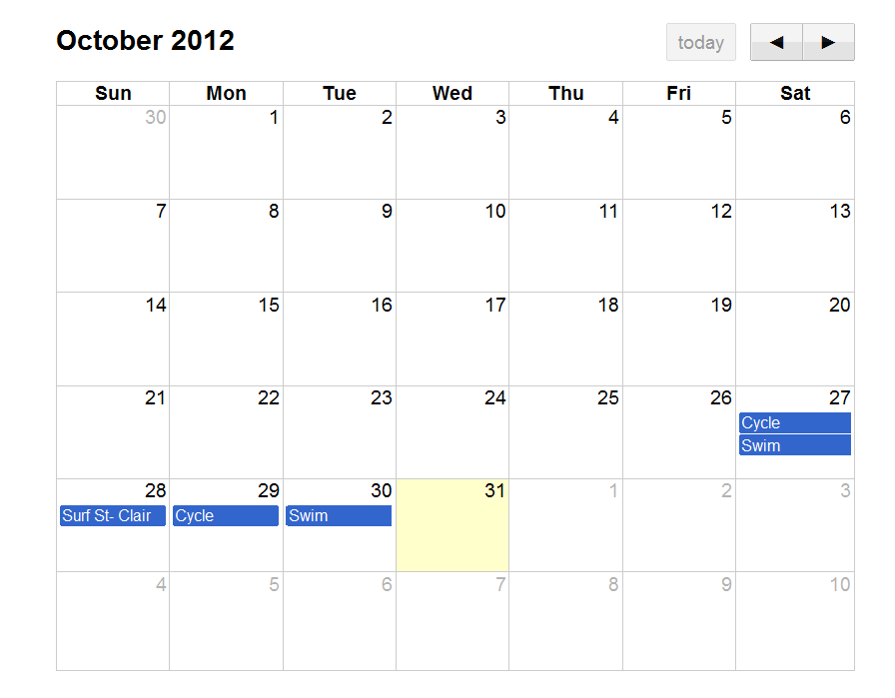

Read the documentation and download latest files at (copy of files in courses folder) <https://fullcalendar.io/download/>

Step 1: Create your tables for your project call this file createTables.php.

Step 2: For this checkpoint lab you need some dummy data, hard code in a user ***dale***, password ***test*** and two days of realistic data.

Step 3: Create a file called events.php that produces output in a JSON format (this format will probably replace XML as a way of passing data. It stands for JavaScript Object Notation).

//mine is a dummy table- only one user, you will need to select for a certain userID

$selectString = "SELECT * FROM tblWorkout";

$result = $pdo->query($selectString);

$events = array();

$color = "green";

foreach($result as $row )

{

$eventArray['title'] = $row['title'];

$eventArray['start'] = $row['date'];

//code a switch on $row['title'] giving each category a color

$eventArray['color'] = $color;

$events[] = $eventArray;

}

echo json_encode($events);

Step 4: The event object has a color property. In the events.php file code a switch statement on $row['title'] and have a third element in each array: $eventArray['color'] = $color;

This file produces the following output to the screen (if you were to run the events.php file and you have completed step 4)

[{"title":"Surf- Aramoana","start":"2016-10-03","color":"green"},{"title":"Gym","start":"2016-10-09","color":"purple"},{"title":"Gym","start":"2016-10-11","color":"purple"},{"title":"Run","start":"2016-10-13","color":"red"},{"title":"Gym","start":"2016-10-18","color":"purple"},{"title":"Run","start":"2016-10-19","color":"red"}]

Step 5: In your project calendarDisplay php file, link to the required javascript files and create a div with an id of calendar for where you want the calendar to appear.

<!DOCTYPE html >

<html>

<head>

<link rel='stylesheet' href='fullcalendar.css' />

<script src='lib/jquery.min.js'></script>

<script src='lib/moment.min.js'></script>

<script src='fullcalendar.js'></script>

<script type='text/javascript'>

$(document).ready(function() {

// page is now ready, initialize the calendar...

$('#calendar').fullCalendar({

// put your options and callbacks here

editable: false,

events: "events.php"

})

});

</script>

<style type='text/css'>

body {

margin-top: 40px;

text-align: center;

font-size: 14px;

font-family: "Lucida Grande",Helvetica,Arial,Verdana,sans-serif;

}

#calendar {

width: 600px;

margin: 0 auto;

}

</style>

</head>

<body>

<div id='calendar'></div>

</body>

</html>